The graph below gives information on the number of participants for different activities at one social centre in Melbourne, Australia for the period 2000 to 2020.
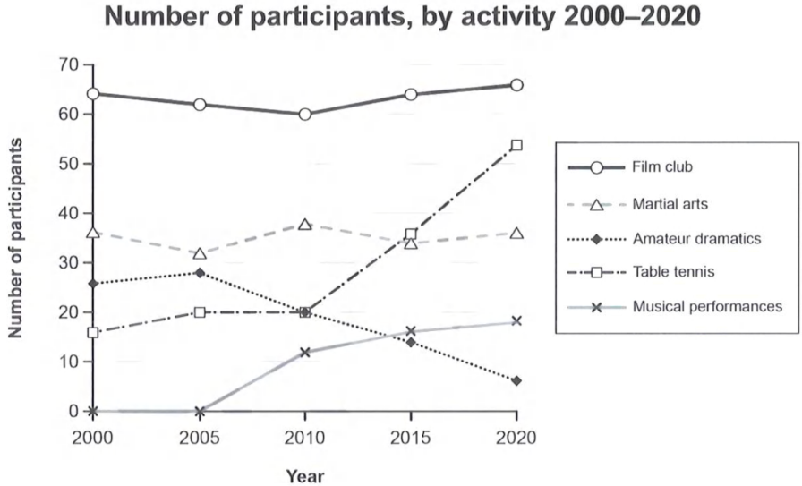
The provided graph illustrates statistical trends related to the number of participants in distinct activities in Melbourne, Australia, at a public gathering space between 2000 and 2020.
Overall, it is evident that the Film Club had more active members, showing a continuous rise in participation, while Martial Arts experienced fluctuations over the period. Meanwhile, Table Tennis saw a dramatic increase in the last decade. Additionally, participation in Amateur Dramatics declined, whereas Musical Performances began to attract people after about half a decade.
A detailed observation indicates that the community center had a positive influence on participants interested in the Film Club, which started with approximately 64 members in 2000 and slowly increased by the end of 2020. In contrast, Martial Arts remained quite popular among contributors, stabilizing at around 35 participants. However, Table Tennis players increased rapidly after 2000, reaching 50 entrants by 2020. Participation in Amateur Dramatics decreased significantly, dropping from nearly 30 to just 7 members during the time interval. Finally, Musical Performances were introduced at the civic center in 2005, quickly attracting interest and climbing to 20 participants by the end of the period.

